Assignment no 3
Task 1
#include <iostream>
#include <string>
#include <fstream>
#include <cstring>
using namespace std;
class bank_account
{
public:
enum account_type { CURRENT, SAVING };
private:
char name[40];
char account_number[30];
account_type type;
double balance_account;
char bank_name[40];
char branch_code[20];
char city[20];
static unsigned int current_count;
static unsigned int saving_count;
public:
bank_account()
{
strcpy_s(name, 40, "unknwon");
strcpy_s(account_number, 30, "000");
strcpy_s(branch_code, 20, "000");
type = CURRENT;
balance_account = 0.0;
strcpy_s(bank_name, 40, "undefine");
strcpy_s(city, 20, "not entered");
current_count++;
}
bank_account(const char* name, const char* account_number, account_type type,
double bal, const char* bank, const char* branch, const char* city)
{
strcpy_s(this->name, 40, name);
strcpy_s(this->account_number, 30, account_number);
this->type = type;
balance_account = bal;
strcpy_s(bank_name, 40, bank);
strcpy_s(branch_code, 20, branch);
strcpy_s(this->city, 20, city);
if (type == CURRENT)
{
current_count++;
}
else
{
saving_count++;
}
}
char* get_account_number()
{
return account_number;
}
~bank_account()
{
if (type == CURRENT)
{
current_count--;
}
else
{
saving_count--;
}
}
void display()
{
cout << "name: " << name << endl;
cout << "bank: " << bank_name << endl;
cout << "city: " << city << endl;
cout << "balance: " << balance_account << endl;
}
static void getAccCounts()
{
cout << "current accounts: " << current_count << endl;
cout << "saving accounts: " << saving_count << endl;
}
void deposit(double amount)
{
balance_account += amount;
}
void inputing_file_info(ofstream& fout)
{
fout << name << " " << account_number << " " << (int)type << " "
<< balance_account << " " << bank_name << " "
<< branch_code << " " << city << endl;
}
bool reading_file(ifstream& fin)
{
int temp;
if (!(fin >> name >> account_number >> temp >> balance_account
>> bank_name >> branch_code >> city))
{
return false;
}
type = (account_type)temp;
if (type == CURRENT)
{
current_count++;
}
else
{
saving_count++;
}
return true;
}
void withdraw(double amount)
{
if (balance_account >= amount)
{
balance_account -= amount;
}
else
{
cout << "balance less than withdraw amount\n";
}
}
};
unsigned int bank_account::current_count = 0;
unsigned int bank_account::saving_count = 0;

int main()
{
bank_account* arr[100];
int total = 0;
ifstream read_file("accounts.txt");

while (total < 100)
{
arr[total] = new bank_account;
if (!arr[total]->reading_file(read_file))
{
delete arr[total];
break;
}
total++;
}
read_file.close();
int choose;
cout << endl;
do {
cout << "1) Create account\n";
cout << "2) display account\n";
cout << "3) deposit\n";
cout << "4) withdraw amount\n";
cout << "5) delete\n";
cout << "6) count\n";
cout << "7) exit\n";
cin >> choose;
if (choose == 1) {
char name[40], acc[30], bank[40], branch[20], city[20];
int type;
double balance;
cout << "name: ";
cin >> name;
cout << "account number: ";
cin >> acc;
cout << "type ( 0) current 1) saving): ";
cin >> type;
cout << "balance: ";
cin >> balance;
cout << "bank name: ";
cin >> bank;
cout << "branch code: ";
cin >> branch;
cout << "city: ";
cin >> city;
arr[total] = new bank_account(name, acc,
(bank_account::account_type)type, balance, bank, branch, city);
total++;
}
else if (choose == 2)
{
for (int i = 0; i < total; i++)
{
arr[i]->display();
}
}

else if (choose == 3)
{
char account_number[30];
double amount;
cout << "account number: ";
cin >> account_number;
cout << "amount: ";
cin >> amount;
for (int i = 0; i < total; i++)
{
if (strcmp(arr[i]->get_account_number(), account_number) == 0) {
arr[i]->deposit(amount);
}
}
}
else if (choose == 4)
{
char account_number[30];
double amount;
cout << "account number: ";
cin >> account_number;
cout << "amount: ";
cin >> amount;
for (int i = 0; i < total; i++)
{
if (strcmp(arr[i]->get_account_number(), account_number) == 0)
arr[i]->withdraw(amount);
}
}
else if (choose == 5)
{
char account_number[30];
cout << "account number to delete: ";
cin >> account_number;
for (int i = 0; i < total; i++)
{
if (strcmp(arr[i]->get_account_number(), account_number) == 0)
{
delete arr[i];
for (int j = i; j < total - 1; j++)
{
arr[j] = arr[j + 1];
}
total--;
break;
}
}
}
else if (choose == 6)
{
bank_account::getAccCounts();
}
} while (choose != 7);
ofstream write_file("accounts.txt");
for (int i = 0; i < total; i++)
{
arr[i]->inputing_file_info(write_file);
delete arr[i];
}
write_file.close();
system("pause");
return 0;
}

OUTPUT
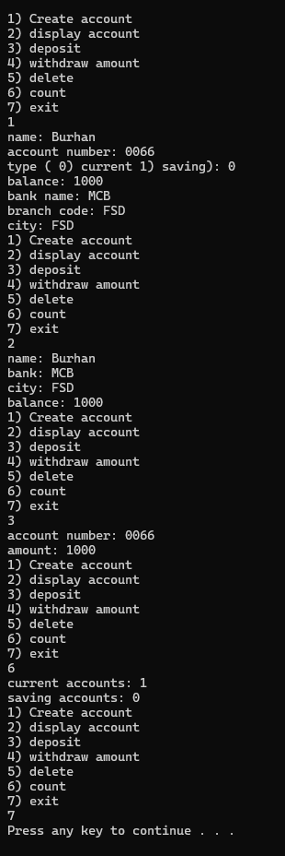

Task 2
# include <iostream>

using namespace std;
class HotDogStand
{
int ID;
int sold;
static int total_sold;
public:
HotDogStand(int ID, int sold)
{
this->ID = ID;
this->sold = sold;
total_sold += sold;
}
void justSold()
{
sold++;
total_sold++;
}
int return_sold()
{
return sold;
}
static int return_total_sold()
{
return total_sold;
}
void display()
{
cout << "id: " << ID << endl;
cout << "sells: " << sold << endl;
cout << "====== ======\n";
}
};
int HotDogStand::total_sold = 0;

int main()
{
HotDogStand active1(0, 99);
HotDogStand active2(2, 0);
HotDogStand active3(4, 100);
active1.justSold();
active2.justSold();
for (int i = 0; i < 3; i++)
{
active3.justSold();
}
cout << "for stand 1\n";
active1.display();
cout << "for stand 2\n";
active2.display();
cout << "for stand 3\n";
active3.display();
cout << "total slaes in stands: " << HotDogStand::return_total_sold() <<
endl;
system("pause");
return 0;
}

OUTOUT
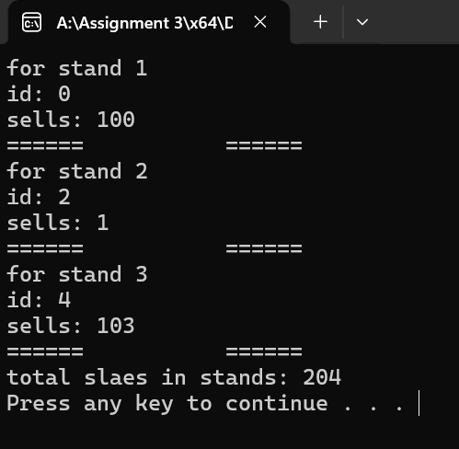

Task 4
#include <iostream>
#include <string>
using namespace std;

class tollbooth
{
unsigned int total_cars;
double total_money;
public:
tollbooth()
{
total_cars = 0;
total_money = 0;
}
void payingCar()
{
total_cars++;
total_money += 50;
}
void noPayCar()
{
total_cars++;
}
void display() const
{
cout << "total cars: " << total_cars << endl;
cout << "total money earned: " << total_money << endl;
}
};
int main()
{
tollbooth car;
while (true)
{
int choose;
cout << "====================menu===================\n";
cout << "1) cars which pays\n";
cout << "2) cars which does not pay\n";
cout << "3) display\n";
cout << "pressing any other key will display\n";
cin >> choose;
if (choose == 1)
{
car.payingCar();
}
else if (choose == 2)
{
car.noPayCar();
}
else if (choose == 3)
{
car.display();
}
else
{
break;
}
}
system("pause");
return 0;
}
OUTPUT
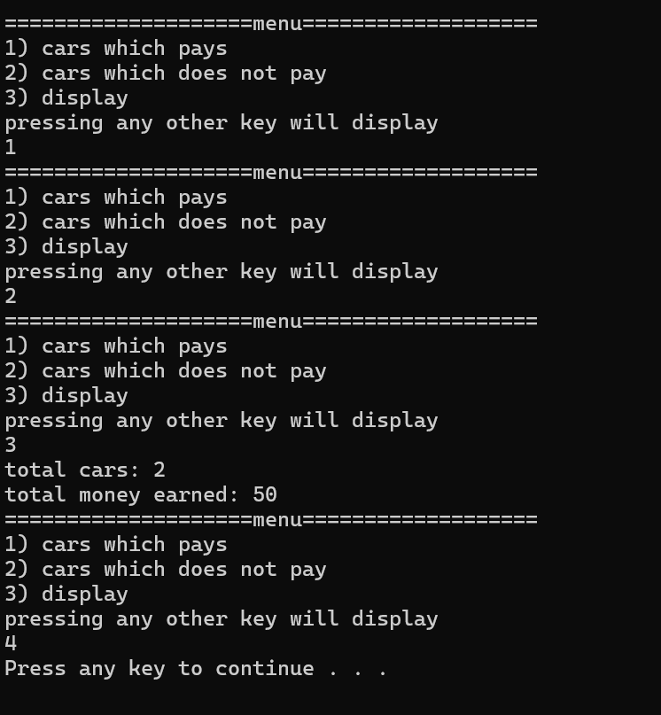

Task 5
#include <iostream>
#include <string>
using namespace std;

class Time
{
int hour;
int min;
int sec;
public:
Time()
{
hour = 0;
min = 0;
sec = 0;
}
Time(int hour, int min, int sec)
{
this->hour = hour;
this->min = min;
this->sec = sec;
}
void display() const
{
cout << "time:" << hour << ":" << min << ":" << sec << endl;
}
void sum(const Time& obj1, const Time& obj2)
{
this->sec = obj1.sec + obj2.sec;
this->min = obj1.min + obj2.min;
this->hour = obj1.hour + obj2.hour;
if (this->sec >= 60)
{
this->min += this->sec / 60;
this->sec %= 60;
}
if (this->min >= 60)
{
this->hour += this->min / 60;
this->min %= 60;
}
}
};

int main()
{
Time num1;
Time num2(1, 20, 10);
Time sum_time;
sum_time.sum(num1, num2);
cout << "diaplay\n";
num1.display();
num2.display();
cout << "display of sum\n";
sum_time.display();
return 0;
}

OUTPUT
